# **Practical – 6**

**AIM: Draw sequence diagram for selected application.**

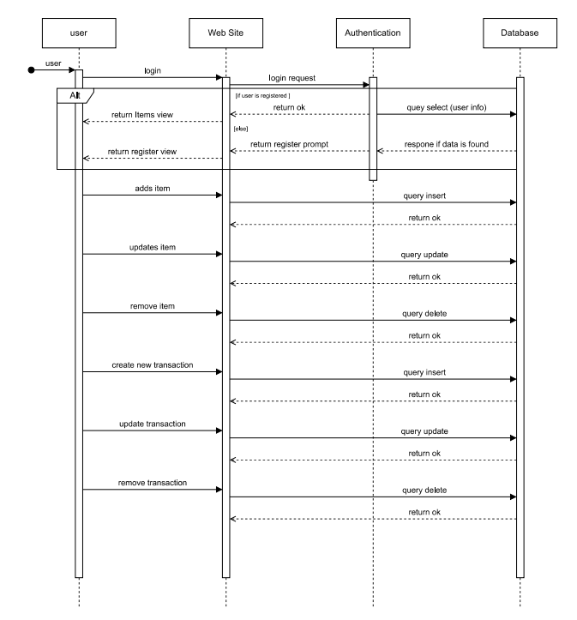**Sequence Diagram:**